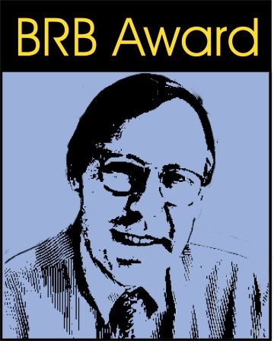

Bernd R. Binder Publication Prize 2019/20
in Vascular Biology & Thrombosis Research

Application form

Name: Klick to fill in
Last Name: Klick to fill in
Email Address: Klick to fill in
Short CV:
Klick to fill in

Title of publication: Klick to fill in
Publication date: Klick to choose date
Journal: Klick to fill in
Impact factor Klick to fill in
Significance to Vascular Biology & Thrombosis Research
Klick to fill in

Area: ☐Vascular Biology ☐Thrombosis Research ☐Clinical ☐Translational ☐Basic

Applicants should send this form and a PDF copy of the paper to awards@technoclone.com by March 31st 2021.

In case I am selected for the prize, I agree to present the publication at the Bernd R. Binder Memorial Lecture at the virtual "Joint Meeting on Vascular Biology, Inflammation and Thrombosis" on April 8th 2021 in Vienna, Austria.

I hereby certify that all co-authors of the paper agree to this submission.

Date:

Signature:

